What is Azure Databricks?
Introduction
In today's digital world, organizations generate massive amounts of data from various sources such as websites, mobile applications, social media, sensors, and business transactions. To extract valuable insights from this data, organizations require powerful analytics and data processing platforms. Azure Databricks is one such cloud-based analytics platform that helps organizations process, analyze, and visualize large volumes of data efficiently.
Azure Databricks is a fully managed Apache Spark-based analytics service provided by Microsoft Azure. It combines the power of big data processing, artificial intelligence, machine learning, and collaborative data analytics into a single platform. It enables data engineers, data scientists, and business analysts to work together and build data-driven solutions quickly and efficiently.
Definition of Azure Databricks
Azure Databricks is a cloud-based data analytics platform built on Apache Spark and optimized for Microsoft Azure. It provides a collaborative environment where users can process large datasets, perform data engineering tasks, develop machine learning models, and generate business insights.
It simplifies big data analytics by automatically managing infrastructure, cluster configuration, scaling, and performance optimization.
What is Apache Spark?
Apache Spark is an open-source distributed computing framework designed for processing large datasets at high speed. It supports:
- Batch Processing
- Real-Time Data Processing
- Machine Learning
- Graph Processing
- Data Analytics
Azure Databricks uses Apache Spark as its core processing engine, making it highly efficient for big data workloads.
Architecture of Azure Databricks
Azure Databricks consists of several components that work together to process and analyze data.
1. Workspace
The workspace is the collaborative environment where users create notebooks, manage clusters, and perform data analysis.
2. Clusters
Clusters are groups of virtual machines used to execute data processing tasks.
Features:
- Automatic scaling
- High performance
- Distributed processing
3. Notebooks
Notebooks provide an interactive environment for writing and executing code.
Supported Languages:
- Python
- SQL
- Scala
- R
4. Databricks Runtime
Databricks Runtime is an optimized version of Apache Spark designed to improve performance and reliability.

5. Azure Storage Integration
Azure Databricks can connect directly with Azure services such as:
- Azure Data Lake Storage
- Azure Blob Storage
- Azure SQL Database
- Azure Synapse Analytics
How Azure Databricks Works
The working process of Azure Databricks involves the following steps:
- Data is collected from various sources.
- Data is stored in Azure Storage services.
- Azure Databricks reads the data.
- Apache Spark processes and transforms the data.
- Analytics and machine learning models are applied.
- Results are visualized and shared with users.
This process enables organizations to gain valuable insights from large datasets.
Features of Azure Databricks
1. Fast Data Processing
Uses Apache Spark for high-speed distributed computing.
2. Collaborative Workspace
Multiple users can work on the same project simultaneously.
3. Interactive Notebooks
Supports coding, visualization, and documentation in a single environment.
4. Machine Learning Support
Provides tools for building and deploying machine learning models.
5. Auto Scaling
Automatically adjusts computing resources based on workload requirements.
6. Security
Offers enterprise-grade security with authentication, authorization, and encryption.
7. Integration with Azure Services
Seamlessly connects with various Azure services for data storage and analytics.
Advantages of Azure Databricks
1. High Performance
Processes large datasets quickly using Apache Spark.
2. Easy Collaboration
Data engineers, analysts, and data scientists can work together efficiently.
3. Scalability
Resources can be scaled automatically according to workload demands.
4. Reduced Infrastructure Management
Azure manages cluster deployment and maintenance.
5. Cost Efficiency
Organizations pay only for the resources they use.
6. Advanced Analytics
Supports artificial intelligence, machine learning, and real-time analytics.
Applications of Azure Databricks
Azure Databricks is widely used in various industries for:
Data Engineering
- Data cleaning
- Data transformation
- ETL processes
Big Data Analytics
- Processing massive datasets
- Business intelligence reporting
Machine Learning
- Predictive analytics
- Recommendation systems
- Fraud detection
Real-Time Analytics
- Streaming data analysis
- IoT applications
Data Warehousing
- Data integration
- Data preparation for reporting
Azure Databricks and ETL
Azure Databricks is commonly used for ETL (Extract, Transform, Load) operations.
Extract
Collect data from multiple sources.
Transform
Clean, process, and structure the data.
Load
Store processed data into databases or data warehouses.
This capability makes Azure Databricks a popular choice for modern data engineering projects.

Difference Between Azure Databricks and Traditional Data Processing
Feature | Traditional Processing | Azure Databricks
Speed | Moderate | Very High
Scalability | Limited | Highly Scalable
Collaboration | Limited | Excellent
Infrastructure Management | Manual | Automated
Big Data Support | Limited | Extensive
Machine Learning | Separate Tools Needed | Built-in Support
Real-World Use Cases
Organizations use Azure Databricks for:
- Customer behavior analysis
- Sales forecasting
- Healthcare analytics
- Fraud detection in banking
- Social media analytics
- Supply chain optimization
- IoT data processing
- Recommendation engines
Challenges of Azure Databricks
Although Azure Databricks offers many benefits, it also has some challenges:
- Learning curve for beginners.
- Requires knowledge of Spark concepts.
- Cost management for large clusters.
- Complex configurations for advanced workloads.
Conclusion
Azure Databricks is a powerful cloud-based analytics platform built on Apache Spark and integrated with Microsoft Azure. It enables organizations to process large volumes of data, perform ETL operations, build machine learning models, and generate valuable business insights. With features such as scalability, high performance, collaborative workspaces, and seamless Azure integration, Azure Databricks has become one of the most widely used tools for big data analytics and data engineering. As organizations continue to adopt data-driven decision-making, Azure Databricks will play a crucial role in modern cloud analytics solutions.
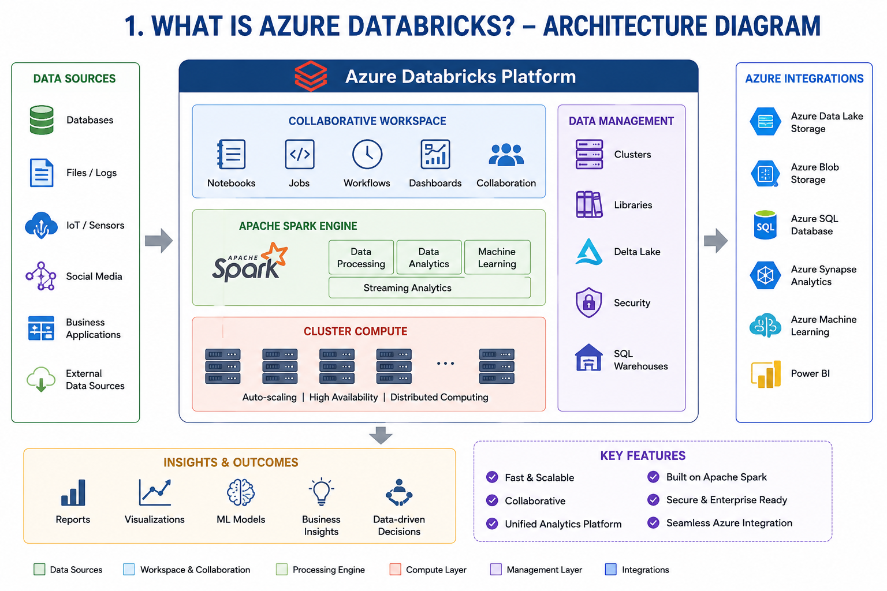

What are the Advantages of Using Azure Databricks?
Introduction
As organizations generate enormous amounts of data every day, they require efficient tools to process, analyze, and derive meaningful insights from that data. Traditional data processing systems often struggle with scalability, performance, and collaboration challenges. Azure Databricks addresses these challenges by providing a powerful cloud-based analytics platform built on Apache Spark and integrated with Microsoft Azure.
Azure Databricks enables organizations to perform big data processing, data engineering, machine learning, and analytics within a unified environment. Its advanced features and seamless integration with Azure services make it one of the most widely used platforms for modern data analytics.
Overview of Azure Databricks
Azure Databricks is a fully managed analytics platform that simplifies the process of working with large datasets. It provides a collaborative workspace where data engineers, data scientists, and business analysts can work together efficiently.
The platform combines the power of Apache Spark with Azure's cloud infrastructure, allowing organizations to process massive amounts of data quickly and securely.
Advantages of Azure Databricks
1. High-Speed Data Processing
One of the biggest advantages of Azure Databricks is its ability to process large datasets at high speed using Apache Spark.
Benefits:
- Faster data processing.
- Reduced execution time.
- Improved analytical performance.
2. Easy Scalability
Azure Databricks automatically scales computing resources based on workload requirements.
Benefits:
- Handles growing data volumes.
- Supports large-scale analytics.
- Improves resource utilization.
3. Collaborative Environment
Azure Databricks provides shared workspaces and interactive notebooks that allow teams to collaborate effectively.
Benefits:
- Improved teamwork.
- Faster project development.
- Better communication among team members.
4. Support for Multiple Programming Languages
Databricks supports several programming languages, including:
- Python
- SQL
- Scala
- R
Benefits:
- Flexibility for developers.
- Easier adoption by different teams.
- Broader development support.
5. Simplified Infrastructure Management
Azure automatically manages cluster creation, configuration, maintenance, and updates.
Benefits:
- Reduced administrative effort.
- Less infrastructure management.
- Increased productivity.
6. Seamless Integration with Azure Services
Azure Databricks integrates with various Azure services, including:
- Azure Data Lake Storage
- Azure Blob Storage
- Azure SQL Database
- Azure Synapse Analytics
- Azure Machine Learning
Benefits:
- Easy data access.
- Unified analytics ecosystem.
- Simplified workflows.
7. Enhanced Machine Learning Capabilities
Azure Databricks provides tools and frameworks for machine learning development.
Benefits:
- Predictive analytics.
- Model training and deployment.
- Artificial Intelligence integration.
8. Real-Time Data Processing
The platform supports streaming and real-time analytics.
Benefits:
- Immediate insights.
- Faster decision-making.
Applications:
- IoT analytics.
- Fraud detection.
- Live dashboards.
9. Cost Efficiency
Azure Databricks follows a pay-as-you-go pricing model.
Benefits:
- No upfront hardware investment.
- Better cost control.
- Pay only for resources used.
10. Enterprise-Level Security
Azure Databricks includes advanced security features.
Security Features:
- Data encryption.
- Role-based access control.
- Azure Active Directory integration.
- Network security controls.
Benefits:
- Protection of sensitive data.
- Compliance with industry regulations.
- Secure user access.
11. Automated Cluster Management
Azure Databricks automatically manages clusters based on workload demands.

Benefits:
- Faster setup.
- Automatic scaling.
- Reduced manual intervention.
12. Interactive Notebooks
Interactive notebooks enable users to write code, execute commands, visualize results, and document processes in one place.
Benefits:
- Better collaboration.
- Simplified data exploration.
- Improved reporting.
13. Delta Lake Support
Azure Databricks supports Delta Lake technology, which improves data reliability and performance.
Benefits:
- ACID transactions.
- Data versioning.
- Improved data quality.
- Faster query performance.
14. Big Data Analytics Support
Azure Databricks is specifically designed for big data workloads.
Benefits:
- Efficient handling of large datasets.
- Distributed computing.
- High-performance analytics.
15. Improved Productivity
By combining data engineering, analytics, and machine learning into a single platform, Azure Databricks significantly improves productivity.
Benefits:
- Faster development cycles.
- Reduced operational complexity.
- Better business outcomes.
Real-World Applications
Azure Databricks is widely used in various industries:
Banking and Finance
- Fraud detection.
- Risk analysis.
- Customer analytics.
Healthcare
- Patient data analysis.
- Medical research.
- Predictive healthcare.
Retail
- Customer behavior analysis.
- Recommendation systems.
- Inventory optimization.
Manufacturing
- Predictive maintenance.
- Supply chain analytics.

Telecommunications
- Network monitoring.
- Real-time performance analysis.
Challenges of Azure Databricks
Although Azure Databricks offers many advantages, some challenges include:
- Learning curve for beginners.
- Cost management for large clusters.
- Need for Spark knowledge.
- Complexity in advanced configurations.
Despite these challenges, the benefits significantly outweigh the limitations.
Conclusion
Azure Databricks is a powerful cloud-based analytics platform that combines Apache Spark with Microsoft Azure's cloud infrastructure. It offers numerous advantages, including high-speed data processing, scalability, collaboration, machine learning support, real-time analytics, strong security, and seamless integration with Azure services. These features make Azure Databricks an ideal solution for organizations seeking efficient and scalable big data analytics. As data continues to grow in volume and importance, Azure Databricks will remain a key technology for modern data engineering and business intelligence solutions.

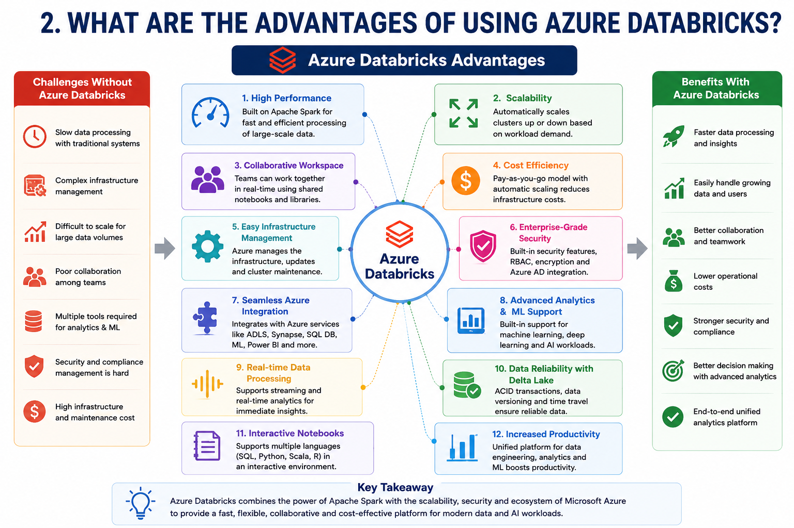

What is a Workspace in Azure Databricks?
Introduction
Azure Databricks is a powerful cloud-based analytics platform that enables organizations to perform data engineering, data analytics, machine learning, and big data processing. To allow teams to collaborate effectively and manage their projects efficiently, Azure Databricks provides a centralized environment known as a Workspace.
A workspace serves as the primary environment where users create, organize, manage, and execute data analytics tasks. It acts as a collaborative platform that allows data engineers, data scientists, and analysts to work together on notebooks, clusters, libraries, and other resources.
Definition of a Workspace
A Workspace in Azure Databricks is a collaborative environment where users can create, store, organize, and manage notebooks, libraries, dashboards, machine learning models, and other project resources.
It provides a centralized location where team members can access and share data analytics projects, making collaboration easier and more efficient.
In simple terms, a workspace is the main working area of Azure Databricks where all development and analytical activities are performed.
Purpose of a Workspace
The primary purpose of a workspace is to provide a shared environment for:
- Data engineering
- Data analytics
- Machine learning
- Collaboration
- Resource management
- Project organization
It enables multiple users to work on the same project while maintaining proper access control and security.
Components of a Workspace
1. Notebooks
Notebooks are interactive documents used to write and execute code.
Supported languages include:
- Python
- SQL
- Scala
- R
Users can combine code, text, visualizations, and results in a single notebook.
2. Clusters
Clusters are groups of virtual machines that provide computing power for processing data.
Functions:
- Execute notebook code.
- Process large datasets.
- Run machine learning workloads.
3. Libraries
Libraries contain reusable code packages and dependencies.
Examples:
- NumPy
- Pandas
- Matplotlib
- TensorFlow
Libraries can be installed and shared across projects.
4. Dashboards
Dashboards help visualize data and analytical results.
Benefits:
- Better decision-making.
- Easy data interpretation.
- Business reporting.

5. Repositories
Repositories allow integration with version control systems such as Git.
Benefits:
- Code version management.
- Team collaboration.
- Project tracking.
How a Workspace Works
The workflow in a Databricks workspace typically follows these steps:
- User logs into Azure Databricks.
- A notebook is created within the workspace.
- A cluster is started.
- Data is loaded from storage services.
- Data processing and analysis are performed.
- Results are visualized and shared.
- Team members collaborate and make updates.
This centralized workflow improves productivity and project management.
Features of Azure Databricks Workspace
Collaborative Environment
Multiple users can work on the same project simultaneously.
Centralized Resource Management
All notebooks, clusters, libraries, and dashboards are managed from one location.
Security and Access Control
Administrators can control user permissions and access levels.

Integration with Azure Services
The workspace integrates with:
- Azure Data Lake Storage
- Azure Blob Storage
- Azure SQL Database
- Azure Synapse Analytics
- Azure Machine Learning
Real-Time Collaboration
Users can edit and share notebooks in real time.
Version Control Support
Supports Git-based repositories for source code management.
Advantages of Using a Workspace
Improved Collaboration
Teams can work together efficiently on data projects.
Better Organization
All project resources are stored in one place.
Increased Productivity
Developers and analysts can focus on data analysis rather than infrastructure management.
Enhanced Security
Provides authentication, authorization, and access control mechanisms.
Easy Project Management
Projects can be organized into folders and shared among teams.
Workspace Structure
A typical Azure Databricks workspace contains:
- Users
- Folders
- Notebooks
- Clusters
- Libraries
- Dashboards
- Repositories
These components work together to support end-to-end analytics workflows.
Real-World Applications
Workspaces are commonly used for:
- Data engineering projects
- ETL pipeline development
- Machine learning model creation
- Business intelligence reporting
- Big data analytics
- Collaborative research projects
Challenges of Workspace Management
Some challenges include:
- Managing large numbers of notebooks.
- Controlling user permissions.
- Organizing project resources effectively.
- Monitoring cluster usage and costs.
Proper workspace governance helps overcome these challenges.

Conclusion
A Workspace in Azure Databricks is a centralized and collaborative environment where users create, manage, and execute data analytics projects. It contains notebooks, clusters, libraries, dashboards, and repositories that help teams perform data engineering, machine learning, and business intelligence tasks efficiently. By providing collaboration, security, scalability, and integration with Azure services, the Databricks Workspace serves as the foundation for all analytics activities within Azure Databricks.
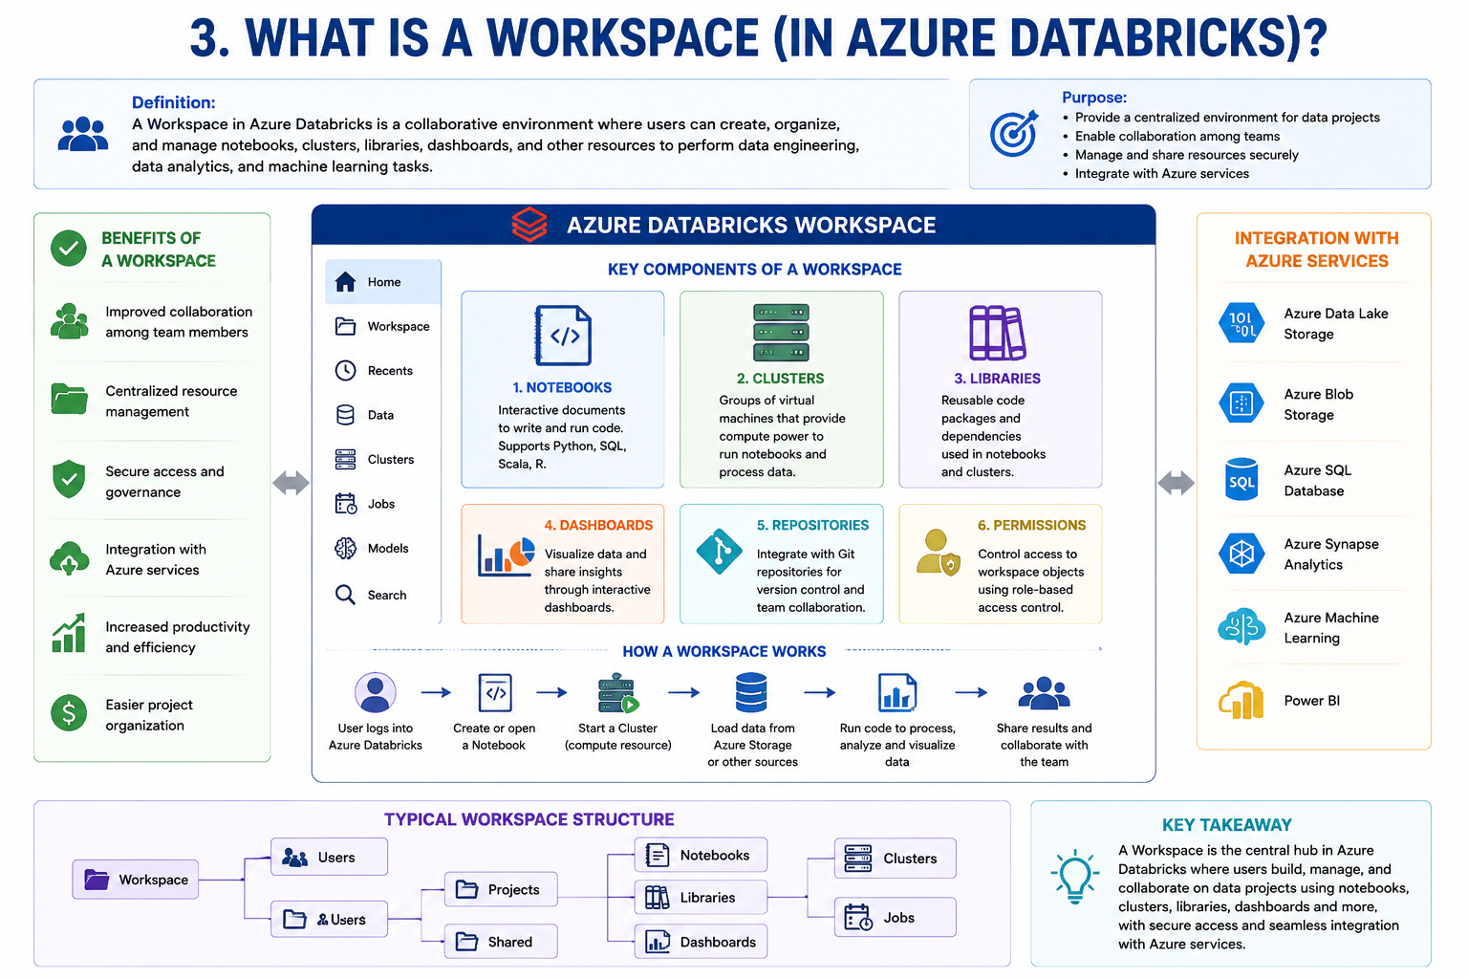

What is EDA (Exploratory Data Analysis)?
Introduction
In data science and data analytics projects, raw data is often incomplete, inconsistent, or difficult to understand. Before applying machine learning algorithms or generating business reports, it is important to analyze and understand the data thoroughly. This process is known as Exploratory Data Analysis (EDA).
EDA is one of the most important steps in the data analysis process because it helps analysts understand the structure, quality, patterns, and relationships within the data. It enables organizations to make informed decisions and prepare data for further analysis and modeling.
Definition of EDA
Exploratory Data Analysis (EDA) is the process of examining, summarizing, visualizing, and understanding datasets to discover patterns, identify anomalies, detect relationships, and gain insights before performing advanced analytics or machine learning.
In simple terms, EDA is the process of exploring data to understand what it contains and how it can be used effectively.
Objectives of EDA
The main objectives of EDA are:
- Understand the dataset.
- Identify missing values.
- Detect outliers.
- Discover patterns and trends.
- Analyze relationships between variables.
- Validate assumptions.
- Prepare data for modeling.
- Improve data quality.

Importance of EDA
EDA plays a crucial role in data analysis because it helps:
1. Understand Data Structure
Provides information about:
- Rows and columns.
- Data types.
- Variable distributions.
2. Identify Data Quality Issues
Helps detect:
- Missing values.
- Duplicate records.
- Incorrect data entries.
3. Discover Patterns
Identifies:
- Trends.
- Correlations.
- Seasonal variations.
4. Improve Decision Making
Allows analysts to make data-driven decisions based on actual insights.
Steps Involved in EDA
Step 1: Data Collection
Gather data from various sources such as:
- Databases
- CSV files
- APIs
- Data warehouses
Step 2: Data Cleaning
Clean the dataset by:
- Removing duplicates.
- Handling missing values.
- Correcting inconsistencies.
Step 3: Data Understanding
Analyze:
- Number of records.
- Features and attributes.
- Data types.
Step 4: Statistical Analysis
Calculate:
- Mean
- Median
- Mode
- Standard deviation
- Variance
Step 5: Data Visualization
Create charts and graphs to understand patterns and trends.
Step 6: Feature Analysis
Study relationships between variables.

Step 7: Data Preparation
Prepare the data for machine learning or reporting.
Types of EDA
1. Univariate Analysis
Analyzes a single variable at a time.
Examples:
- Age distribution
- Salary distribution
Techniques:
- Histograms
- Frequency tables
- Pie charts
2. Bivariate Analysis
Analyzes the relationship between two variables.
Examples:
- Salary vs Experience
- Sales vs Advertising
Techniques:
- Scatter plots
- Correlation analysis
3. Multivariate Analysis
Analyzes relationships among multiple variables.
Examples:
- Sales influenced by price, marketing, and season.
Techniques:
- Heatmaps
- Pair plots
- Regression analysis
Common EDA Techniques
Descriptive Statistics
Provides numerical summaries of data.
Examples:
- Mean
- Median
- Mode
- Range
Correlation Analysis
Measures relationships between variables.
Examples:
- Positive correlation
- Negative correlation
Outlier Detection
Identifies unusual observations.
Methods:
- Box plots
- Z-score analysis
Missing Value Analysis
Detects and handles missing data.
Methods:
- Remove missing values.
- Replace with mean or median.
Data Visualization in EDA
Visualization helps understand data quickly.
Common visualizations include:
Histogram
Shows data distribution.
Bar Chart
Compares categories.
Pie Chart
Displays proportions.
Scatter Plot
Shows relationships between variables.
Box Plot
Detects outliers and spread of data.
Heatmap
Displays correlation between variables.
Tools Used for EDA
Popular tools include:
- Python
- Pandas
- NumPy
- Matplotlib
- Seaborn
- Jupyter Notebook
- Azure Databricks
- Apache Spark
EDA in Azure Databricks
Azure Databricks is widely used for EDA because it provides:
- Interactive notebooks.
- Large-scale data processing.
- Data visualization support.
- SQL and Python integration.
- Collaborative analytics environment.
Analysts can perform EDA on millions of records efficiently using Databricks and Apache Spark.
Applications of EDA
EDA is used in:
Banking
- Fraud detection.
- Risk analysis.
Healthcare
- Patient data analysis.
- Disease prediction.
Retail
- Customer behavior analysis.
- Sales forecasting.

Marketing
- Campaign performance analysis.
Manufacturing
- Quality control.
- Predictive maintenance.
Benefits of EDA
- Better understanding of data.
- Improved data quality.
- Enhanced decision making.
- Reduced modeling errors.
- Identification of hidden patterns.
- More accurate machine learning models.
Challenges of EDA
- Large datasets can be difficult to analyze.
- Data quality issues may affect results.
- Time-consuming for complex datasets.
- Requires domain knowledge.
Conclusion
Exploratory Data Analysis (EDA) is a critical step in the data analytics and machine learning lifecycle. It helps analysts understand datasets, identify data quality issues, discover patterns, and prepare data for further analysis. By using statistical methods and visualizations, EDA provides valuable insights that improve decision-making and ensure successful analytical outcomes. In modern platforms such as Azure Databricks, EDA can be performed efficiently on large-scale datasets, making it an essential practice for data professionals.
